Face Detection in Jetson nano

This project is a real-time face recognition system implemented in Python using the face_recognition, OpenCV, and dlib libraries. It loads known faces from a dataset and identifies them via webcam input. Ideal for security systems, attendance systems, or personal use.

**How the System Works**

1. **Dataset Preparation**:  
   Add clear images of each person into known_faces/<name>/.
2. **Encoding Faces**:  
   During runtime, the script loads all images and encodes facial features.
3. **Real-time Recognition**:  
   Captures frames from webcam → Detects faces → Compares with known encodings → Displays results.

### Step by step instructions :

**Step 1:**

Create an new repository and redirect to that repository

**Step 2:**

Install the following libraries and packages

pip install face_recognition opencv-python numpy pillow

sudo apt-get install cmake

pip install dlib==19.22.99

**Step 3:**

**Connect an USB cam or CSI camera in the jetson nano and run the following program**

import cv2

import os

import tkinter as tk

from tkinter import ttk

from tkinter import messagebox

from PIL import Image, ImageTk

class FaceCaptureApp:

def __init__(self, root):

self.root = root

self.root.title("Face Capture GUI")

self.root.geometry("700x300") # Smaller window

# Variables

self.person_name = tk.StringVar()

self.mode = tk.StringVar(value="auto")

self.save_path = ""

self.count = 0

self.frame_count = 0

self.capture_running = False

self.frame = None

# GUI Layout

self.setup_gui()

# OpenCV

self.cap = None

def setup_gui(self):

# Input for name

tk.Label(self.root, text="Person Name:").grid(row=0, column=0, padx=5, pady=5, sticky="e")

tk.Entry(self.root, textvariable=self.person_name).grid(row=0, column=1, padx=5, pady=5)

# Mode dropdown

tk.Label(self.root, text="Mode:").grid(row=1, column=0, padx=5, pady=5, sticky="e")

ttk.Combobox(self.root, textvariable=self.mode, values=["auto", "manual"], state="readonly").grid(row=1, column=1, padx=5, pady=5)

# Buttons

tk.Button(self.root, text="Start Capture", command=self.start_capture).grid(row=2, column=0, padx=5, pady=5)

tk.Button(self.root, text="Stop", command=self.stop_capture).grid(row=2, column=1, padx=5, pady=5)

# Capture Button (manual mode only)

self.capture_btn = tk.Button(self.root, text="Capture Image", command=self.capture_image)

self.capture_btn.grid(row=3, column=0, columnspan=2, padx=5, pady=5)

self.capture_btn.config(state="disabled")

# Status label

self.status_label = tk.Label(self.root, text="Status: Idle", fg="blue")

self.status_label.grid(row=4, column=0, columnspan=2)

# Image count

self.count_label = tk.Label(self.root, text="Images Captured: 0")

self.count_label.grid(row=5, column=0, columnspan=2)

# Video panel

self.video_panel = tk.Label(self.root)

self.video_panel.grid(row=0, column=2, rowspan=6, padx=10)

def start_capture(self):

name = self.person_name.get().strip()

if not name:

messagebox.showwarning("Input Error", "Please enter a name.")

return

self.save_path = os.path.join("face_dataset", name)

os.makedirs(self.save_path, exist_ok=True)

self.cap = cv2.VideoCapture(0)

if not self.cap.isOpened():

messagebox.showerror("Error", "Could not open webcam.")

return

# Smaller resolution

self.cap.set(cv2.CAP_PROP_FRAME_WIDTH, 320)

self.cap.set(cv2.CAP_PROP_FRAME_HEIGHT, 240)

self.capture_running = True

self.count = 0

self.frame_count = 0

self.status_label.config(text="Status: Capturing...", fg="green")

if self.mode.get() == "manual":

self.capture_btn.config(state="normal")

self.root.after(10, self.video_loop)

def stop_capture(self):

self.capture_running = False

if self.cap:

self.cap.release()

self.status_label.config(text="Status: Stopped", fg="red")

self.video_panel.config(image='') # Clear video feed

self.capture_btn.config(state="disabled")

def capture_image(self):

if self.frame is not None:

face_img = cv2.resize(self.frame, (224, 224))

img_name = os.path.join(self.save_path, f"{self.count}.jpg")

cv2.imwrite(img_name, face_img)

self.count += 1

self.count_label.config(text=f"Images Captured: {self.count}")

self.status_label.config(text=f"Saved: {img_name}", fg="blue")

def video_loop(self):

if not self.capture_running:

return

ret, frame = self.cap.read()

if not ret:

return

self.frame = frame.copy()

# Auto capture

if self.mode.get() == "auto" and self.frame_count % 5 == 0:

self.capture_image()

self.frame_count += 1

# Convert image to RGB and resize to match preview size

rgb_frame = cv2.cvtColor(frame, cv2.COLOR_BGR2RGB)

img = Image.fromarray(rgb_frame).resize((320, 240))

imgtk = ImageTk.PhotoImage(image=img)

self.video_panel.imgtk = imgtk

self.video_panel.configure(image=imgtk)

self.root.after(10, self.video_loop)

# Run the GUI

if __name__ == "__main__":

root = tk.Tk()

app = FaceCaptureApp(root)

root.mainloop()

**While running the program please ensure that you’re inside the desired project repo then on successful running of the program the GUI will open**

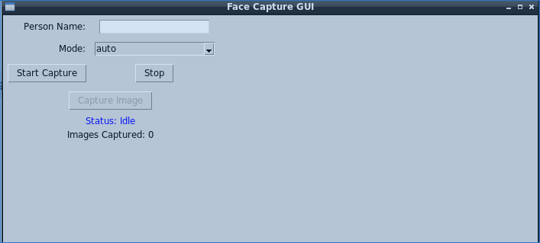

**Enter the person’s name and select the model then start capturing the image the collected images will be stored under separate folders**

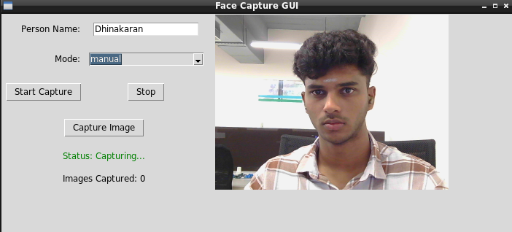  
  


**Then we can start training the model with the collected data for training the model use this code**import os

import cv2

import face_recognition

import pickle

DATASET_PATH = "face_dataset"

ENCODINGS_FILE = "face_encodings.pkl"

known_encodings = []

known_names = []

for person_name in os.listdir(DATASET_PATH):

person_path = os.path.join(DATASET_PATH, person_name)

if not os.path.isdir(person_path):

continue

for image_name in os.listdir(person_path):

image_path = os.path.join(person_path, image_name)

image = cv2.imread(image_path)

rgb_image = cv2.cvtColor(image, cv2.COLOR_BGR2RGB)

encodings = face_recognition.face_encodings(rgb_image)

if len(encodings) > 0:

known_encodings.append(encodings[0])

known_names.append(person_name)

data = {"encodings": known_encodings, "names": known_names}

with open(ENCODINGS_FILE, "wb") as f:

pickle.dump(data, f)

print(f"✅ Training complete. {len(known_names)} faces encoded.")

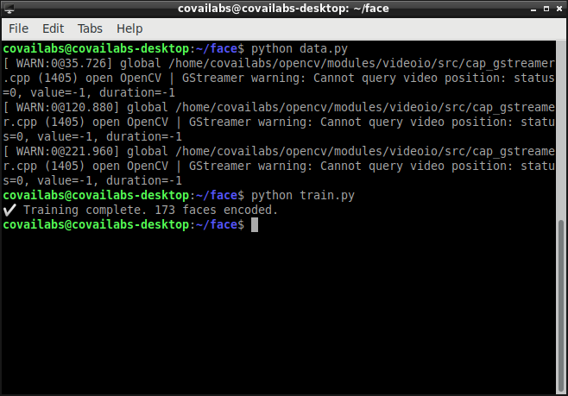

**When the training is completed a new file with .pkl extension will be created in your repository that will contains the encodings of the training data**

Then run the following program for detection  
  
import cv2

import face_recognition

import pickle

import threading

# Load trained face encodings

with open("face_encodings.pkl", "rb") as f:

data = pickle.load(f)

# Extract the encodings and names

known_faces = data["encodings"]

known_names = data["names"]

# Start video capture from the webcam

video_capture = cv2.VideoCapture(0)

# Set the resolution to a lower value for faster processing (e.g., 640x480)

video_capture.set(3, 640) # Width

video_capture.set(4, 480) # Height

print("📷 Starting webcam... Press 'q' to quit.")

frame_skip_rate = 2 # Number of frames to skip (e.g., 2 means process every 2nd frame)

frame_count = 0

# Function to process each frame in a separate thread

def process_frame(frame):

global frame_count

# Resize the frame to speed up face recognition

rgb_frame = cv2.cvtColor(frame, cv2.COLOR_BGR2RGB)

# Detect faces in the frame

face_locations = face_recognition.face_locations(rgb_frame)

face_encodings = face_recognition.face_encodings(rgb_frame, face_locations)

# Loop through each face found in the frame

for (top, right, bottom, left), face_encoding in zip(face_locations, face_encodings):

# Compare the detected face with known faces

matches = face_recognition.compare_faces(known_faces, face_encoding)

name = "Unknown"

# If a match is found, use the name of the matched person

if True in matches:

index = matches.index(True)

name = known_names[index]

# Draw a rectangle around the face and display the name

cv2.rectangle(frame, (left, top), (right, bottom), (0, 255, 0), 2)

cv2.putText(frame, name, (left, top - 10), cv2.FONT_HERSHEY_SIMPLEX, 0.8, (0, 255, 0), 2)

# Display the resulting frame

cv2.imshow("Face Recognition", frame)

frame_count += 1

if cv2.waitKey(1) & 0xFF == ord("q"):

return False # Exit loop

return True

while True:

ret, frame = video_capture.read()

if not ret:

break

# Skip processing frames based on frame_skip_rate

if frame_count % frame_skip_rate == 0:

# Process the current frame in a separate thread

if not process_frame(frame):

break

# Continue to the next frame

frame_count += 1

# Release the video capture and close the window

video_capture.release()

cv2.destroyAllWindows()

**It will start the detection**

